Thank you for your interest in the Course Specification for **MAAL 7631 Research Project** within the Master of Arts in Applied Linguistics program.

Please be informed that the current course specification available on our website is based on **Template T-104 (2022 edition)**. As of September 1, 2024, the updated course specification utilizing Template **TPG-153 (2023 edition)** has not been received for upload. Additionally, we have not yet received a Word document version of the updated specification for this course.

While there are no significant differences between Template T-104 (2022) and Template TPG-153 (2023), please be aware that there may be updates pertaining to specific course codes, course content and the **Specification Approval Date** in the newer version that are not with the website team for upload yet.

Our website team is committed to providing the most current information and will promptly upload updated course specifications as they are received.

We appreciate your understanding and thank you for your patience.

**Notice Regarding Course Specification Update for MAAL 7631 Research Project – Master of Arts in Applied Linguistics**

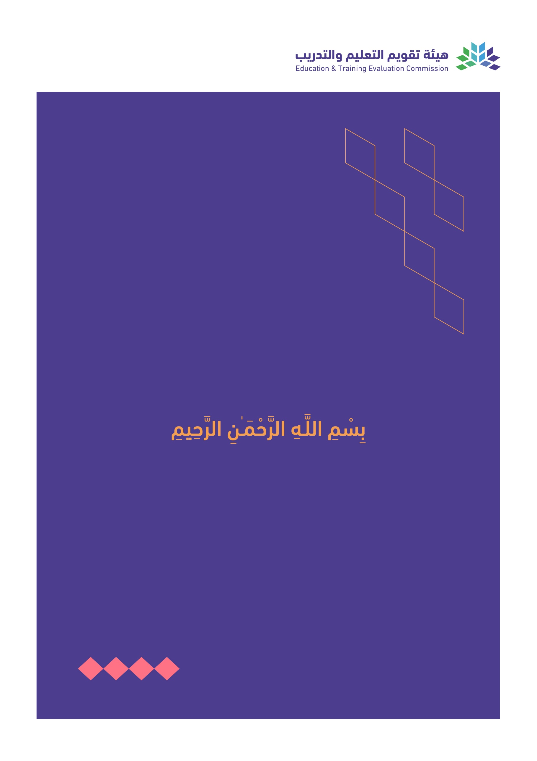

T3

2022

T-104

2022

Course Specification

|  |
| --- |
| Course Title: **Research Project** |
| Course Code:  **MAAL 7631** |
| Program:  **Master of Arts in Applied Linguistics** |
| Department:  **English Department** |
| College:  **Faculty of Languages and Translation** |
| Institution:  **King Khalid University** |
| Version: Updated |
| Last Revision Date: **January 28, 2023** |

Table of Contents:

|  |  |
| --- | --- |
| Content | Page |
| 1. General Information about the course | 3 |
| 1. Teaching mode  2. Contact Hours | 3 |
| B. Course Learning Outcomes, Teaching Strategies and Assessment Methods | 4 |
| C. Course Content | 4 |
| D. Student Assessment Activities | 4 |
| E. Learning Resources and Facilities | 5 |
| 1. References and Learning Resources | 5 |
| 2. Required Facilities and Equipment | 5 |
| F. Assessment of Course Quality | 5 |
| G. Specification Approval Data | 5 |

# A. General information about the course:

|  |  |  |  |
| --- | --- | --- | --- |
| **Course Identification** | | | |
| **1. Credit hours:** | | 6 | |
| **2. Course type** | | | |
| a. | University  College  Department Track Others | | |
| b. | Required  Elective | | |
| **3. Level/year at which this course is offered:** | | | **Level 6/6th Semester** |
| **4. Course general Description:** Project (MAAL 542) is a course introduced to MA students in their level 4. It has 3 contact/credit hours. This course aims to demonstrate to students how to carry out research in Applied Linguistics and guide them to develop a research project of their own. It focuses on providing students with tools that will help them to design and write a research project. | | | |
| **5. Pre-requirements for this course (if any): MAAL7531-Research methods and Training** | | | |
| **6. Co- requirements for this course (if any): N/A** | | | |
| **7. Course Main Objective(s):** This course aims at familiarizing M.A. students with the practical aspects of research in Applied Linguistics. They are introduced to major themes in the areas of Applied Linguistics most commonly selected by researchers. Initially, the students learn how to develop a research hypothesis and proposal; select an appropriate research method or design, analyze and interpret the data, and report the findings. By the end of the course, they are expected to write their own research project. | | | |

## 1. Teaching mode (mark all that apply)

| No | Mode of Instruction | Contact Hours | Percentage |
| --- | --- | --- | --- |
|  | Traditional classroom | 60 | 100% |
|  | E-learning |  |  |
|  | Hybrid   * Traditional classroom * E-learning |  |  |
|  | Distance learning |  |  |

## 

## 2. Contact Hours (based on the academic semester)

|  |  |  |
| --- | --- | --- |
| No | Activity | Contact Hours |
|  | Lectures | 60 |
|  | Laboratory/Studio |  |
|  | Field |  |
|  | Tutorial |  |
|  | Others (specify) |  |
|  | Total | 60 |

# Course Learning Outcomes (CLOs), Teaching Strategies and Assessment Methods

| Code | Course Learning Outcomes | Code of CLOs aligned with program | Teaching Strategies | Assessment Methods |
| --- | --- | --- | --- | --- |
| 1.0 | Knowledge and understanding | | | |
| 1.1 | Outline the differences between the theoretical and practical aspects of research. | K 5 | Lectures  Class discussions  Presentations | Assignment (1) |
| 1.2 | Explain the differet types of possible areas of research in the field of Applied Linguistics. | K 5 | Lectures  Class discussions  Presentations | Assignment (1) |
| 1.3 | Describe the step sof conducting a research project. | K 5 | Lectures  Class discussion. Problem-solving sessions Tutorial | Research project |
| 2.0 | Skills | | | |
| 2.1 | Apply the research methods they learn to research local and global applied linguistic issues. | S 2 | Lectures  Class discussions  Presentations | Assignment (2) |
| 2.2 | Formulate a clear and practical research questions and hypotheses. | S 5 | Lectures  Class discussions  Presentations | Assignment (2) |
| 2.3 | Make use of technology to collect relevant data, analyze, and interpret it. | S 4 | Lectures  Class discussions  Presentations | Assignment (3) |
| 2.4 | Analyze the problems related to applied linguistics and develop initial solutions. | S 2 | Lectures  Class discussions  Presentations | Assignment (4) |
| 2.5 | Write a research paper using techniques they learn in research methods. | S 5 | Lectures  Class discussions  Presentations | Research project |
| 3.0 | Values, autonomy, and responsibility | | | |
| 3.1 | Demonstrate professional, self-dependence, and self-confidence in executing a research project. | V 1 | Lectures and class participation | Research project |
| 3.2 | Act responsibly and ethically in carrying out the research project. | V 1 | Lectures and class participation | Reports and research project |
| 3.3 | Work successfully in pairs and groups in participating in research projects. | V 4 | Lectures and class participation | Project work and discussions |

# C. Course Content

|  |  |  |
| --- | --- | --- |
| No | List of Topics | Contact Hours |
| 1 | Major themes in Applied linguistics | 8 |
| 2 | Research Topics: Finding a topic; features of a good research topic | 9 |
| 3 | Developing research proposal: statement of the problem, research questions, objectives, hypotheses, limitation and significance of the study, review of earlier literature. | 9 |
| 4 | Guidelines for thesis writing: note-taking and drafting; writing introduction and conclusion; section on methodology; reporting results; documentation and referencing | 9 |
| 5 | Writing a research paper: Step-by-step guidance | 9 |
| 6 | Submission of project | 8 |
| 7 | Oral examination | 8 |
| **Total** | | 60 |

# 

# **D. Students Assessment Activities**

| No | Assessment Activities * | Assessment timing  (in week no) | Percentage of Total Assessment Score |
| --- | --- | --- | --- |
| **1** | Assignment (1) Research proposal | 4 | 5 % |
| **2** | Assignment (2) Research paper: Introduction, Related literature, and Methodology part | 7 | 5 % |
| **3** | Assignment (3) Research paper: Data collection, Analysis, and Discussion | 9 | 5 % |
| **4** | Assignment (4) Rewriting Method part with Results, Discussion, Conclusion, and Implications | 10 | 5 % |
| **5** | First Draft Submission | 11 | 15 % |
| **6** | Revising first draft and meeting the supervisor to get ready for the oral exam | - | - |
| **7** | Final Draft Submission | 12 | 50 % |
| **8** | Final Oral Examination | 13 | 15% |

*Assessment Activities (i.e., Written test, oral test, oral presentation, group project, essay, etc.)

# E. Learning Resources and Facilities

## 1. References and Learning Resources

|  |  |
| --- | --- |
| Essential References | 1. O'Leary, Z. (2017). The Essential Guide to Doing Your Research Project. 3rd ED, London: SAGE. 2. Wagenen, R. K. (1991). Writing a Thesis: Substance and Style, New Jersey: Prentice Hall.   Bitchener, J. (2010). Writing an Applied Linguistics Thesis or Dissertation, Palgrave: Macmillan. |
| Supportive References | 1. MLA Handbook for Writers of Research Papers, 7th Ed. Joseph Gibaldi, The Modern Languages Association, paperback Edition,2009.   Publication Manual of the American Psychological Association (7th ed.), Washington, DC: American Psychological Association. |
| Electronic Materials | Saudi Digital Library: https://sdl.edu.sa/sdlportal/en/publishers.aspx |
| Other Learning Materials | Tarone E, Gass, S. & Cohen, A. (1994). Research Methodology in Second Language Acquisition. New Jersy. |

## 

## 2. Required Facilities and equipment

| Items | Resources |
| --- | --- |
| facilities  (Classrooms, laboratories, exhibition rooms, simulation rooms, etc.) | Classroom |
| Technology equipment  (projector, smart board, software) | Data show projector |
| Other equipment  (depending on the nature of the specialty) | NA |

# F. Assessment of Course Quality

| Assessment Areas/Issues | Assessor | Assessment Methods |
| --- | --- | --- |
| Effectiveness of teaching | Students, Instructors, Program Leaders | Tests, Surveys, Interviews |
| Effectiveness of students’ assessment | Measurement and Evaluation Unit | Analysis of course evaluation questionnaires, SPSS Analysis Repot |
| Quality of learning resources | Students, Instructors, Program Leaders | Observations, Surveys |
| The extent to which CLOs have been achieved | Instructors, Program Leaders | Tests, portfolios |
| Other |  |  |

**Assessor** (Students, Faculty, Program Leaders, Peer Reviewer, Others (specify)

**Assessment Methods** (Direct, Indirect)

# G. Specification Approval Data

|  |  |
| --- | --- |
| Council /COMMittee |  |
| Reference No. |  |
| Date |  |