Thank you for your interest in the Course Specification for **MAAL 7411 Language Pedagogy and Curriculum Development** within the Master of Arts in Applied Linguistics program.

Please be informed that the current course specification available on our website is based on **Template T-104 (2022 edition)**. As of September 1, 2024, the updated course specification utilizing Template **TPG-153 (2023 edition)** has not been received for upload. Additionally, we have not yet received a Word document version of the updated specification for this course.

While there are no significant differences between Template T-104 (2022) and Template TPG-153 (2023), please be aware that there may be updates pertaining to specific course codes, course content and the **Specification Approval Date** in the newer version that are not with the website team for upload yet.

Our website team is committed to providing the most current information and will promptly upload updated course specifications as they are received.

We appreciate your understanding and thank you for your patience.

**Notice Regarding Course Specification Update for MAAL 7411 Language Pedagogy and Curriculum Development – Master of Arts in Applied Linguistics**

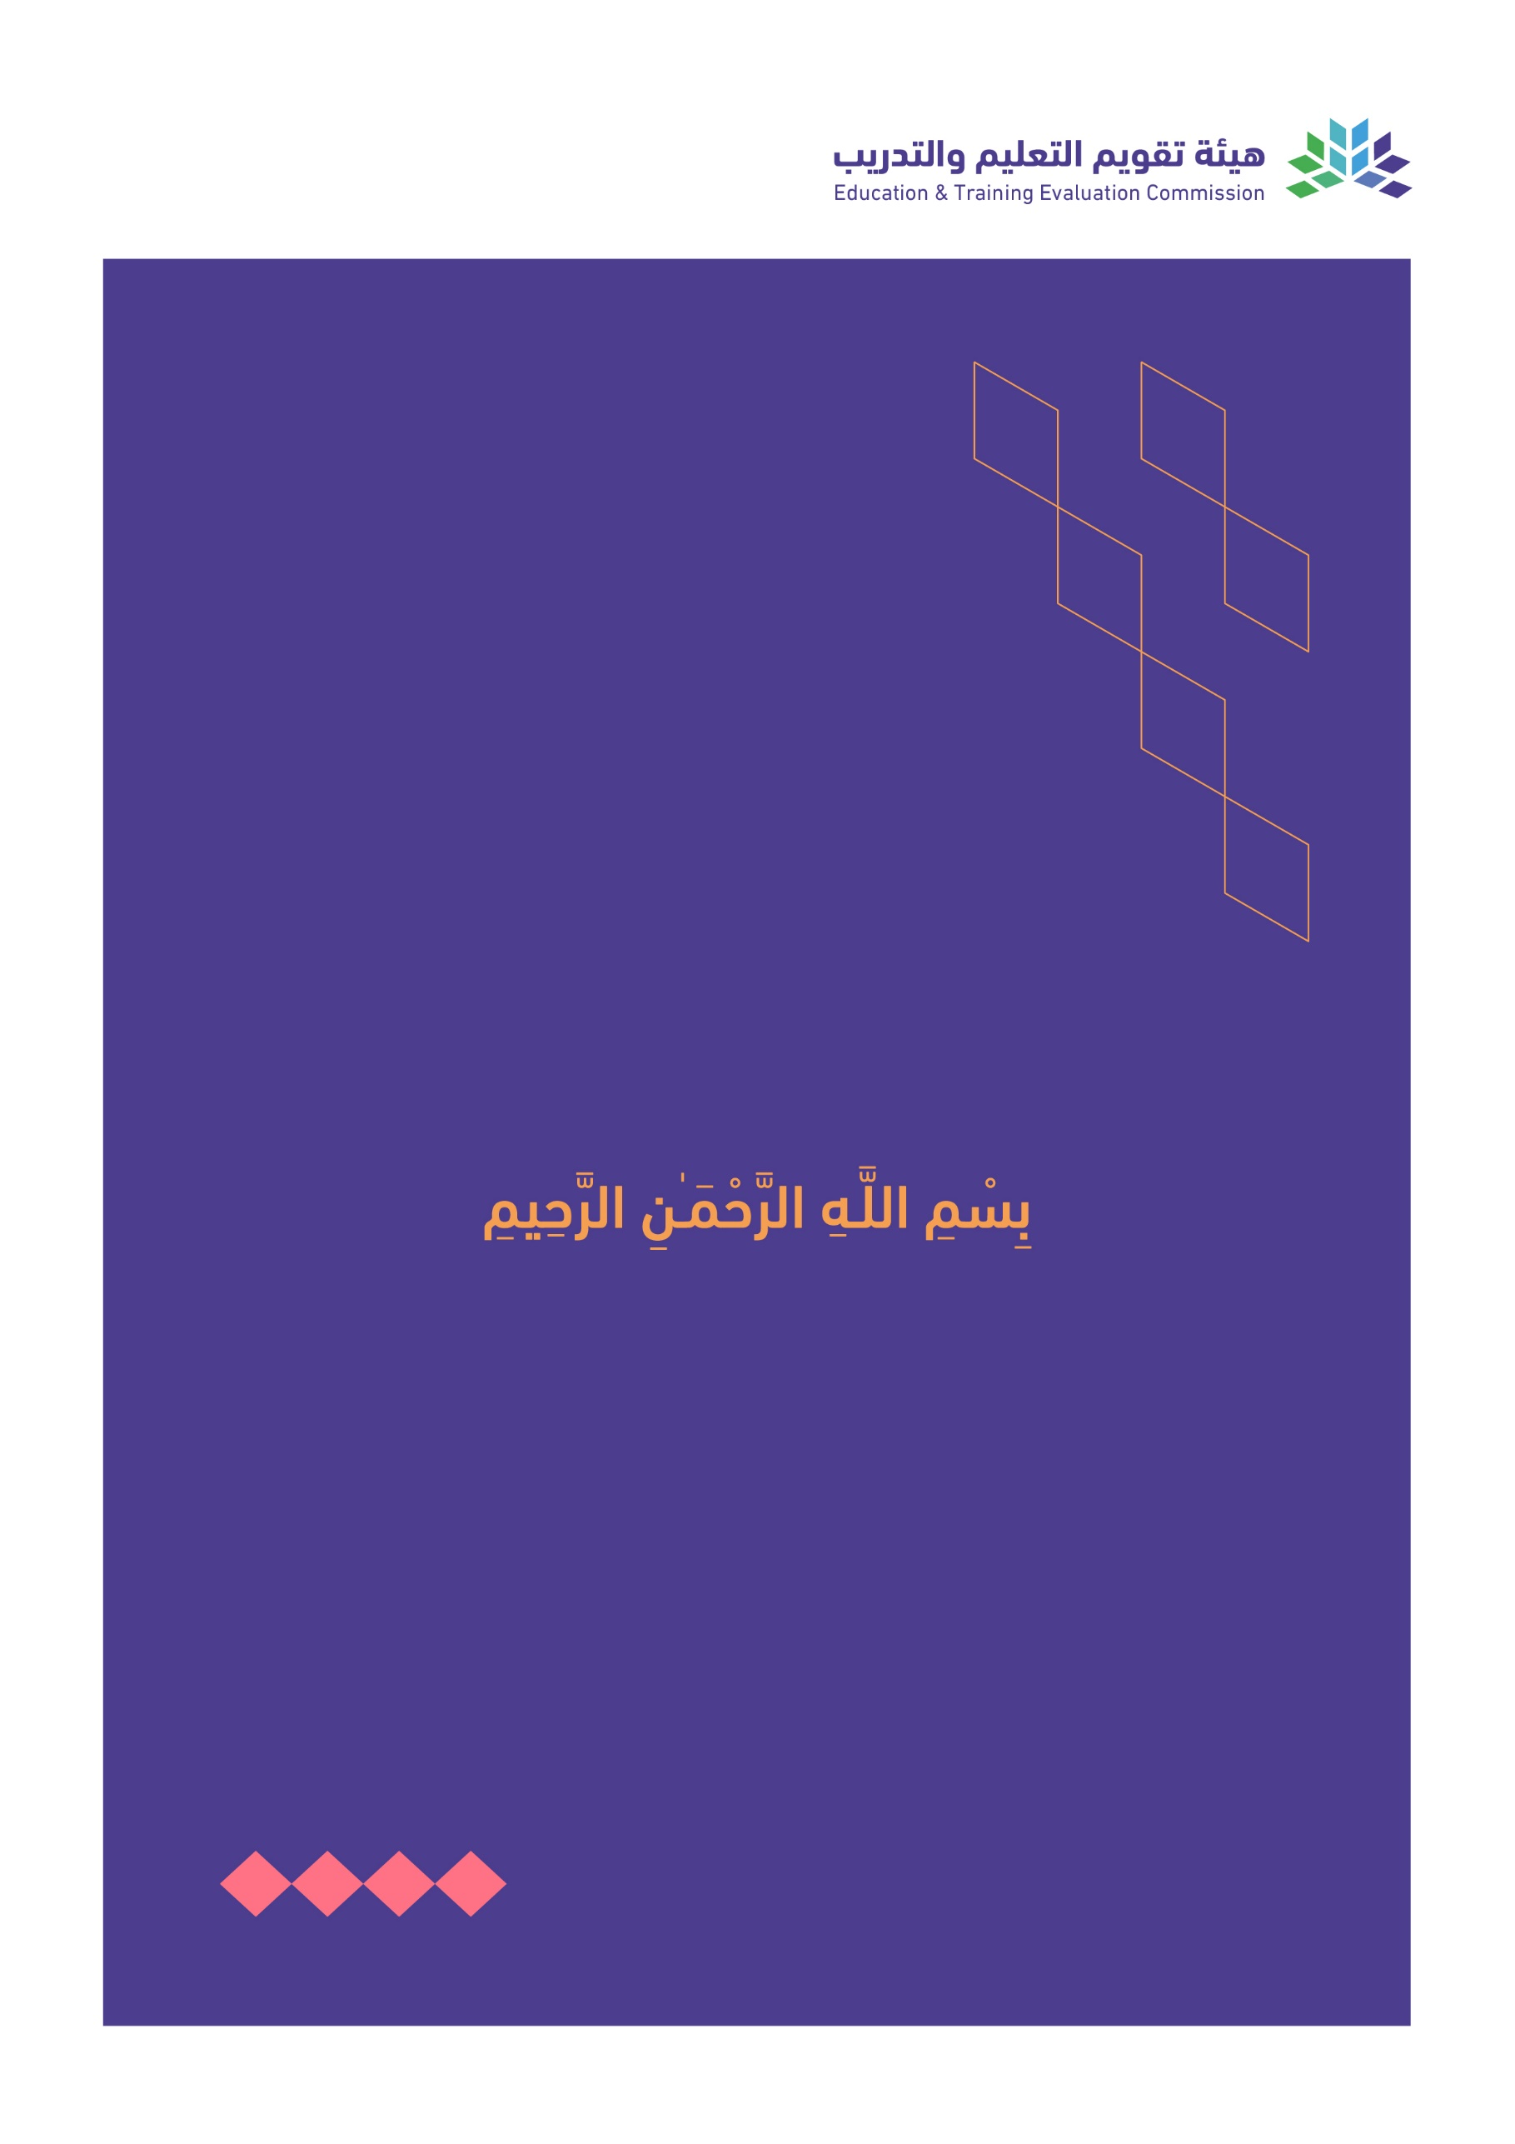

T3

2022

T-104

2022

Course Specification

|  |
| --- |
| Course Title: **Language Pedagogy and Curriculum Development** |
| Course Code:  **MAAL 7411** |
| Program:  **Master of Arts in Applied Linguistics** |
| Department:  **English Department** |
| College:  **Faculty of Languages and Translation** |
| Institution:  **King Khalid University** |
| Version: Updated |
| Last Revision Date: **January 28, 2023** |

Table of Contents:

|  |  |
| --- | --- |
| Content | Page |
| 1. General Information about the course | 3 |
| 1. Teaching mode  2. Contact Hours | 3 |
| B. Course Learning Outcomes, Teaching Strategies and Assessment Methods | 4 |
| C. Course Content | 4 |
| D. Student Assessment Activities | 4 |
| E. Learning Resources and Facilities | 5 |
| 1. References and Learning Resources | 5 |
| 2. Required Facilities and Equipment | 5 |
| F. Assessment of Course Quality | 5 |
| G. Specification Approval Data | 5 |

# A. General information about the course:

|  |  |  |  |
| --- | --- | --- | --- |
| **Course Identification** | | | |
| **1. Credit hours:** | | 6 | |
| **2. Course type** | | | |
| a. | University  College  Department Track Others | | |
| b. | Required  Elective | | |
| **3. Level/year at which this course is offered:** | | | **Level 4/ 4th Semester** |
| **4. Course general Description:** Crystal-clear and comprehensive yet concise, Language Pedagogy and Curriculum Development course is designed to assist students in developing learning/ teaching skills essential for curriculum designing, planning, and implementation at the different institutions’ site they work in. Three paramount processes; curriculum development, assessment, and teaching practices will be emphasized in regard to relevant theory, research, and practice. A bird’s eye view will be set on the role of responsible leadership practicum leadership in assuring that these processes function effectively. The course will explore also first and second language acquisition, English language teaching, learning styles, needs analysis, the effects of culture on learning, and ways to make content comprehensible to the ESL students in the general classroom. Curriculum will be analyzed to ensure success for language learners since teaching has always been doubted to be successful; to that end, a clinical setting for the demonstration of theory applied to practice will be an integral part of the course. | | | |
| **5. Pre-requirements for this course (if any): N/A** | | | |
| **6. Co- requirements for this course (if any): N/A** | | | |
| **7. Course Main Objective(s):**  Upon successful completion of this course, the student will:   * Align content and language pedagogy standards to design effective lesson plans across students’ varied levels of language proficiency. * Appraise, select, and integrate learners’ needs analysis as a core benchmark standard to fit the learners’ needs. * Reflect on and evaluate the complex process of differential instruction for English Language Learners as it directly applies to their current and future classroom instructional and management/organizational practices. * Apply theoretical principles of language learning to instructional planning’ delivery. * Design and scaffold teaching techniques using multiple teaching strategies to meet the core competencies as well as language skills and sub-skills of the target language learners | | | |

## 1. Teaching mode (mark all that apply)

| No | Mode of Instruction | Contact Hours | Percentage |
| --- | --- | --- | --- |
|  | Traditional classroom | 60 | 100% |
|  | E-learning |  |  |
|  | Hybrid   * Traditional classroom * E-learning |  |  |
|  | Distance learning |  |  |

## 

## 2. Contact Hours (based on the academic semester)

|  |  |  |
| --- | --- | --- |
| No | Activity | Contact Hours |
|  | Lectures | 60 |
|  | Laboratory/Studio |  |
|  | Field |  |
|  | Tutorial |  |
|  | Others (specify) |  |
|  | Total | 60 |

# Course Learning Outcomes (CLOs), Teaching Strategies and Assessment Methods

| Code | Course Learning Outcomes | Code of CLOs aligned with program | Teaching Strategies | Assessment Methods |
| --- | --- | --- | --- | --- |
| 1.0 | Knowledge and understanding | | | |
| 1.1 | Identify the major steps in the curriculum design process. | K1 | Lecturing Discussion, Practicing writing formats. | Teaching Practice Tests. |
| 1.2 | Locate lesson plans that reflect a solid understanding of content knowledge and comprehension of students that engages students in significant learning. | K2 | Projects/ Demos | Teaching Practice |
| 1.3 | Relate students with effective and clear techniques with high quality teaching activities to adhere the students’ levels knowledge. | K3 | Presentations given by student. | designing lessons, mini-courses |
| 2.0 | Skills | | | |
| 2.1 | Calibrate students to acquire skills necessary for evaluating language teaching materials in current textbooks. | S1 | Align all assignments to address the target objective(s). | Include a description of course assignments/ activities, including the evaluation criteria, and a course grading scale. |
| 2.2 | Adapt/ develop adequate materials for language teaching and language testing. | S2 | Include in-class activities/ assessments to measure the mastery of the skills listed left. | Lesson plan &  Reflection paper. |
| 2.3 | Assemble students in reflective practice course which combines face-to-face classes on topics related to practical aspects of teaching EFL classes and fieldwork experience including EFL class observations and supervised teaching. | S3 | In-class demos | Portfolio.  Lesson plan.  Model lesson plan. |
| 3.0 | Values, autonomy, and responsibility | | | |
| 3.1 | Initiate teaching skills to tailor the local culture. | V1 | One hour of instructor-led discussion per week. | Align assignments to the objectives so that it meets the values listed on the left side of the table. |
| 3.2 | Employ the ethical local values to adhere them with the professional teaching constraints. | V2 | Outline a basic framework for what to do, how to do, and how to know about the local Saudi setting. | Reflection paper.  Online discussion. |
| 3.3 | Develop a critical view of curriculum design as it relates to Saudi’s EFL context and needs. | V3 | Elicit a critical view of curriculum design as it relates to Saudi EFL/ ESL context. | Teaching practice assignments to measure the relativity of the designed Reading texts & Listening audio with the Saudi local setting. |

# 

# C. Course Content

|  |  |  |
| --- | --- | --- |
| No | List of Topics | Contact Hours |
| 1 | Language Curriculum Design: An Overview | 4 |
| 2 | Environment Analysis | 6 |
| 3 | Needs Analysis | 4 |
| 4 | Principles | 4 |
| 5 | Goals, Content and Sequencing | 6 |
| 6 | Format and Presentation | 4 |
| 7 | Monitoring and Assessment | 4 |
| 8 | Evaluation | 4 |
| 9 | Approaches to Curriculum Design | 4 |
| 10 | Negotiated Syllabuses | 4 |
| 11 | Adopting and Adapting an Existing Course Book | 4 |
| 12 | Introducing Change | 4 |
| 13 | Planning an In-Service Course | 4 |
| 14 | Teaching and Curriculum Design | 4 |
| **Total** | | 60 |

# **D. Students Assessment Activities**

| No | Assessment Activities * | Assessment timing  (in week no) | Percentage of Total Assessment Score |
| --- | --- | --- | --- |
| **1** | First Progress Test. | 3 | 15% |
| **2** | Second Progress Test. | 6 | 15% |
| **3** | Teaching Practice/ Assignments | Weekly | 20% |
| **4** | Final Exam | 13 | 50% |

*Assessment Activities (i.e., Written test, oral test, oral presentation, group project, essay, etc.)

# E. Learning Resources and Facilities

## 1. References and Learning Resources

|  |  |
| --- | --- |
| Essential References | I.S.P. Nation and John Macalister, (2010). *Language Curriculum Design,* New York: Routledge.  Jack C. Richards, (2017). *Curriculum Development in Language Teaching*, Cambridge: Cambridge University Press. |
| Supportive References | Kathleen Graves, (2000). *Designing Language Courses: A Guide for Teachers,* New York and London: Heinle & Heinle.  Victoria Russel, Kathryn Murphy-Judy, (2020). *Teaching Language Online, A Guide for Designing, Developing, and Delivering Online, Blended, and Flipped Language Courses*, Routledge.  Diane Larsen-Freeman & Marti Anderson, (2011). *Techniques & Principles in Language Teaching,* Third Edition, Oxford.  Jim Scrivener, *Learning Teaching, (2011). The Essential Guide to English Language Teaching,* Third Edition, Macmillan Books for Teachers.  Jean -Claude Beacco, Mike Fleming, Francis Goullier, Eike Thümann, Helmut Volmer, Joseph Shells, (2016). *A Handbook for Curriculum Development and teacher Training, The Language Dimensions in All Subjects.* Council of Europe Publishing, Strasbourg Cedex. |
| Electronic Materials | Journal of Curriculum & Pedagogy  http://www.curriculumandpedagogy.org/Journal.html Online Articles on Language Pedagogy. http://epistemic-forms.com/FacSite/Articles-Pedagogy.html |
| Other Learning Materials | Published papers on Language Learning materials and Teaching. |

## 2. Required Facilities and equipment

| Items | Resources |
| --- | --- |
| facilities  (Classrooms, laboratories, exhibition rooms, simulation rooms, etc.) | Classroom- 20 seats with a white board and a data projector. |
| Technology equipment  (projector, smart board, software) | Laptop. |
| Other equipment  (depending on the nature of the specialty) | N/A |

# F. Assessment of Course Quality

| Assessment Areas/Issues | Assessor | Assessment Methods |
| --- | --- | --- |
| Effectiveness of teaching | Students, Instructors, Program Leaders | Tests, Surveys, Interviews |
| Effectiveness of students’ assessment | Measurement and Evaluation Unit | Analysis of course evaluation questionnaires, SPSS Analysis Repot |
| Quality of learning resources | Students, Instructors, Program Leaders | Observations, Surveys |
| The extent to which CLOs have been achieved | Instructors, Program Leaders | Tests, portfolios |
| Other |  |  |

**Assessor** (Students, Faculty, Program Leaders, Peer Reviewer, Others (specify)

**Assessment Methods** (Direct, Indirect)

# G. Specification Approval Data

|  |  |
| --- | --- |
| Council /COMMittee |  |
| Reference No. |  |
| Date |  |