Thank you for your interest in the Course Specification **MAAL 7211 Language Acquisition** within the Master of Arts in Applied Linguistics program.

Please be informed that the current course specification available on our website is based on **Template T-104 (2022 edition)**. As of September 1, 2024, the updated course specification utilizing Template **TPG-153 (2023 edition)** has not been received for upload. Additionally, we have not yet received a Word document version of the updated specification for this course.

While there are no significant differences between Template T-104 (2022) and Template TPG-153 (2023), please be aware that there may be updates pertaining to specific course codes, course content and the **Specification Approval Date** in the newer version that are not with the website team for upload yet.

Our website team is committed to providing the most current information and will promptly upload updated course specifications as they are received.

We appreciate your understanding and thank you for your patience.

**Notice Regarding Course Specification Update for MAAL 7211 Language Acquisition – Master of Arts in Applied Linguistics**

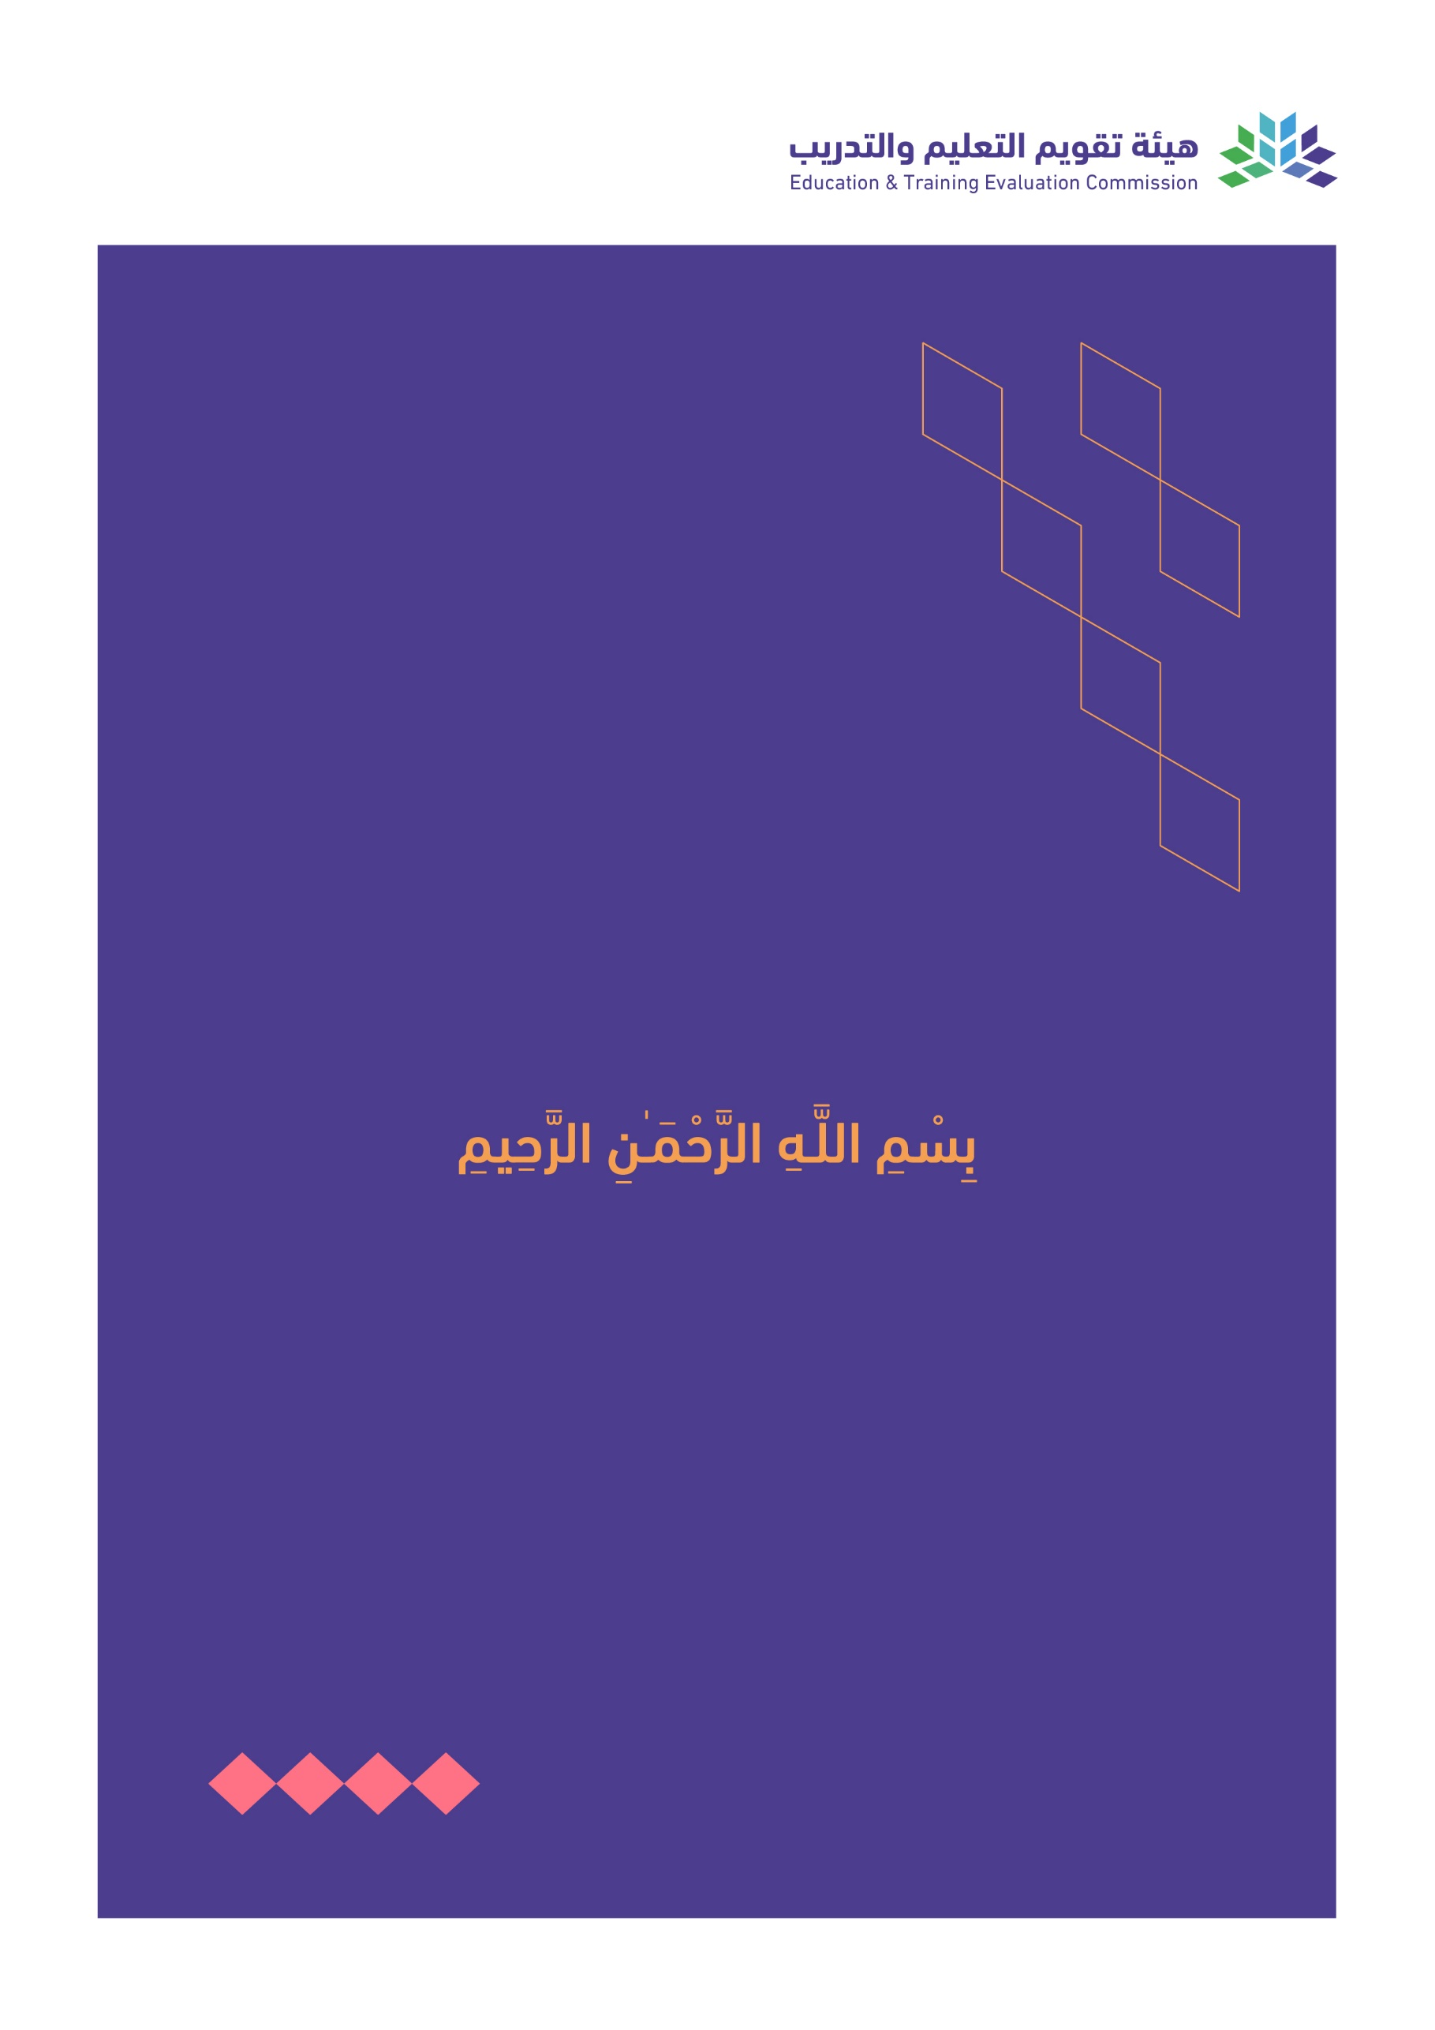

T3

2022

T-104

2022

Course Specification

|  |
| --- |
| Course Title: **Language Acquisition** |
| Course Code:  **MAAL 7211** |
| Program:  **Master of Arts in Applied Linguistics** |
| Department:  **English Department** |
| College:  **Faculty of Languages and Translation** |
| Institution:  **King Khalid University** |
| Version: Updated |
| Last Revision Date: **January 28, 2023** |

Table of Contents:

|  |  |
| --- | --- |
| Content | Page |
| 1. General Information about the course | 3 |
| 1. Teaching mode  2. Contact Hours | 3 |
| B. Course Learning Outcomes, Teaching Strategies and Assessment Methods | 4 |
| C. Course Content | 4 |
| D. Student Assessment Activities | 4 |
| E. Learning Resources and Facilities | 5 |
| 1. References and Learning Resources | 5 |
| 2. Required Facilities and Equipment | 5 |
| F. Assessment of Course Quality | 5 |
| G. Specification Approval Data | 5 |

# A. General information about the course:

|  |  |  |  |
| --- | --- | --- | --- |
| **Course Identification** | | | |
| **1. Credit hours:** | | 4 | |
| **2. Course type** | | | |
| a. | University  College  Department Track Others | | |
| b. | Required  Elective | | |
| **3. Level/year at which this course is offered:** | | | **Level 2/ 2nd Semester** |
| **4. Course general Description:** The course introduces students to the field of second language acquisition. It starts with introducing how languages are acquired natively and then moves on to knowing and reflecting on how second languages are acquired and/or learned. The course introduces a historical overview of SLA theories leading to present day contentions. The course allows ample opportunities for students to reflect on their own acquisition and/or learning of English as a second/foreign language. | | | |
| **5. Pre-requirements for this course (if any): N/A** | | | |
| **6. Co- requirements for this course (if any): N/A** | | | |
| **7. Course Main Objective(s):** The main objective of this course is to provide students with in-depth knowledge of SLA field by which they could reflect, evaluate, and examine their own experiences as learners of a second/foreign language. Then, they would extend their knowledge to empower/guide others who are undertaking second/foreign language learning endeavor. | | | |

## 1. Teaching mode (mark all that apply)

| No | Mode of Instruction | Contact Hours | Percentage |
| --- | --- | --- | --- |
|  | Traditional classroom | 36 | 90% |
|  | E-learning | 4 | 10% |
|  | Hybrid   * Traditional classroom * E-learning |  |  |
|  | Distance learning |  |  |

## 

## 2. Contact Hours (based on the academic semester)

|  |  |  |
| --- | --- | --- |
| No | Activity | Contact Hours |
|  | Lectures | 40 |
|  | Laboratory/Studio |  |
|  | Field |  |
|  | Tutorial |  |
|  | Others (specify) |  |
|  | Total | 40 |

# Course Learning Outcomes (CLOs), Teaching Strategies and Assessment Methods

| Code | Course Learning Outcomes | Code of CLOs aligned with program | Teaching Strategies | Assessment Methods |
| --- | --- | --- | --- | --- |
| 1.0 | Knowledge and understanding | | | |
| 1.1 | Describe basic issues in second language acquisition | K1.1 | * Lectures * Discussions | * Assignments * Midterm exams * Final exams |
| 1.2 | Explain theories and issues in the field of second language acquisition (SLA). | K1.1, K1.2, & K1.4 | * In-class discussions * Group work * Pair work | * Assignments * Midterm exams * Final exams |
| 1.3 | Identify the role of factors that facilitate or hinder the first and second language acquisition | K1.2, K1.3 | * Lectures * In-class discussions * Group work * Pair work | * Assignments * Midterm exams * Final exams |
| 1.4 | Explain the process of second language acquisition and development | K1.4 | * Lectures * In-class discussions | * Assignments * Midterm exams * Final exams |
| 2.0 | Skills | | | |
| 2.1 | Critically examine their own language learning/teaching experiences. | 2.1,2.2,&2.3 | * Presentations * In-class discussions * Midterm exams | * Assignments * Midterm exams * Final exams |
| 2.2 | Reflect on SLA theories in library-research paper and reports | 2.1, 2.2, 2.5 | * Presentations * In-class discussions * Midterm exams | A term paper |
| 2.3 | Apply the most effective findings and reflections of various issues in SLA to learn L2 | 2.5 & 2.4 | * Presentations * In-class discussions * Midterm exams | * Oral presentation * Observation |
| 2.4 | Analyze second language learners’ performance to communicate in their L2 | 2.3 | * Presentations * In-class discussions * Midterm exams | * Oral presentation * Observation |
| 3.0 | Values, autonomy, and responsibility | | | |
| 3.1 | Maintain academic integrity in their papers and reports. | V3.1, V3.3,  V 3.4 | * Checking for plagiarism | * Assignments and reports |
| 3.2 | Monitor and reflect on their progress as L2 learners considering SLA theories. | V3.2, V3.3 | * In-class discussions | * Presentations |
| 3.3 | Assess the progress of other L2 learners based on their acquired knowledge | V3.5 | * Presentations * Group works | Assignments   * Midterm exams |
| 3.4 | Understand the individual differences among L2 learners in light of SLA | V 3.3 | * In class discussions * Group works | Assignments   * Midterm exams |

# C. Course Content

|  |  |  |
| --- | --- | --- |
| No | List of Topics | Contact Hours |
| 1 | Introducing Key Issues in Second Language Acquisition | 4 |
| 2 | Foundations of Second Language Acquisition | 6 |
| 3 | Early Development of SLA: from contrastive analysis to monitor model | 6 |
| 4 | Acquiring knowledge for L2 use | 3 |
| 5 | Linguistic universals | 3 |
| 6 | Cognitive theory | 3 |
| 7 | Interlanguage in context | 3 |
| 8 | Input, interaction and output | 3 |
| 9 | The lexicon and vocabulary acquisition | 3 |
| 10 | Individual learner differences | 3 |
| 11 | L2 learning and teaching | 3 |
| **Total** | | 40 |

# **D. Students Assessment Activities**

| No | Assessment Activities * | Assessment timing  (in week no) | Percentage of Total Assessment Score |
| --- | --- | --- | --- |
| **1** | Mid-term Exam (1) | 3 | 15% |
| **2** | Mid-term Exam (2) | 6 | 15% |
| **3** | Papers, projects, and assignments | 5 to 10 | 20% |
| **4** | Final exam | 13 | 50% |

*Assessment Activities (i.e., Written test, oral test, oral presentation, group project, essay, etc.)

# E. Learning Resources and Facilities

## 1. References and Learning Resources

|  |  |
| --- | --- |
| Essential References | * Saville-Troike, M., & Barto, K. (2017). Introducing second language acquisition. Cambridge University Press. * Gass, S. M. (2013). Second language acquisition: An introductory course. Routledge. |
| Supportive References | * Ellis, R. (1994). The study of second language acquisition. Oxford: Oxford univeristy press. * Doughty, C.J. & Long, M.H. (2003) The Handbook of Second Language Acquisition. Oxford: Blackwell. * Gass, S. & Selinker, L. (2008) Second Language Acquisition: An Introductory Course. New Jersey: Lawrence Erlbaum |
| Electronic Materials | * Second Language Acquisition Topics (Vivian Cook, 2003): http://homepage.ntlworld.com/vivian.c/SLA/ * Second Language Acquisition Bibliography (Vivian Cook, 2003): http://homepage.ntlworld.com/vivian.c/SLA/SLABIB/index.htm * Language Acquisition http://www.ling.lancs.ac.uk/chimp/langac/LECTURE10/10home.htm * Overview of SLA Theories (Elizabeth Murphy, 2000):http://www.ucs.mun.ca/~emurphy/Frenchoverview/ |
| Other Learning Materials | - SPSS or any other statistics software that may help in analyzing SLA data. |

## 2. Required Facilities and equipment

| Items | Resources |
| --- | --- |
| facilities  (Classrooms, laboratories, exhibition rooms, simulation rooms, etc.) | Equipped classrooms |
| Technology equipment  (projector, smart board, software) | Data show, computers, smart boards, and sound system |
| Other equipment  (depending on the nature of the specialty) | N/A |

# F. Assessment of Course Quality

| Assessment Areas/Issues | Assessor | Assessment Methods |
| --- | --- | --- |
| Effectiveness of teaching | Students, Instructors, Program Leaders | Tests, Surveys, Interviews |
| Effectiveness of students’ assessment | Measurement and Evaluation Unit | Analysis of course evaluation questionnaires, SPSS Analysis Repot |
| Quality of learning resources | Students, Instructors, Program Leaders | Observations, Surveys |
| The extent to which CLOs have been achieved | Instructors, Program Leaders | Tests, portfolios |
| Other |  |  |

**Assessor** (Students, Faculty, Program Leaders, Peer Reviewer, Others (specify)

**Assessment Methods** (Direct, Indirect)

# G. Specification Approval Data

|  |  |
| --- | --- |
| Council /COMMittee |  |
| Reference No. |  |
| Date |  |