Thank you for your interest in the Course Specification for **MAAL 7101 Advanced Academic Writing** within the Master of Arts in Applied Linguistics program.

Please be informed that the current course specification available on our website is based on **Template T-104 (2022 edition)**. As of September 1, 2024, the updated course specification utilizing Template **TPG-153 (2023 edition)** has not been received for upload. Additionally, we have not yet received a Word document version of the updated specification for this course.

While there are no significant differences between Template T-104 (2022) and Template TPG-153 (2023), please be aware that there may be updates pertaining to specific course codes, course content and the **Specification Approval Date** in the newer version that are not with the website team for upload yet.

Our website team is committed to providing the most current information and will promptly upload updated course specifications as they are received.

We appreciate your understanding and thank you for your patience.

**Notice Regarding Course Specification Update for MAAL 7101 Advanced Academic Writing – Master of Arts in Applied Linguistics**

T-104

2022

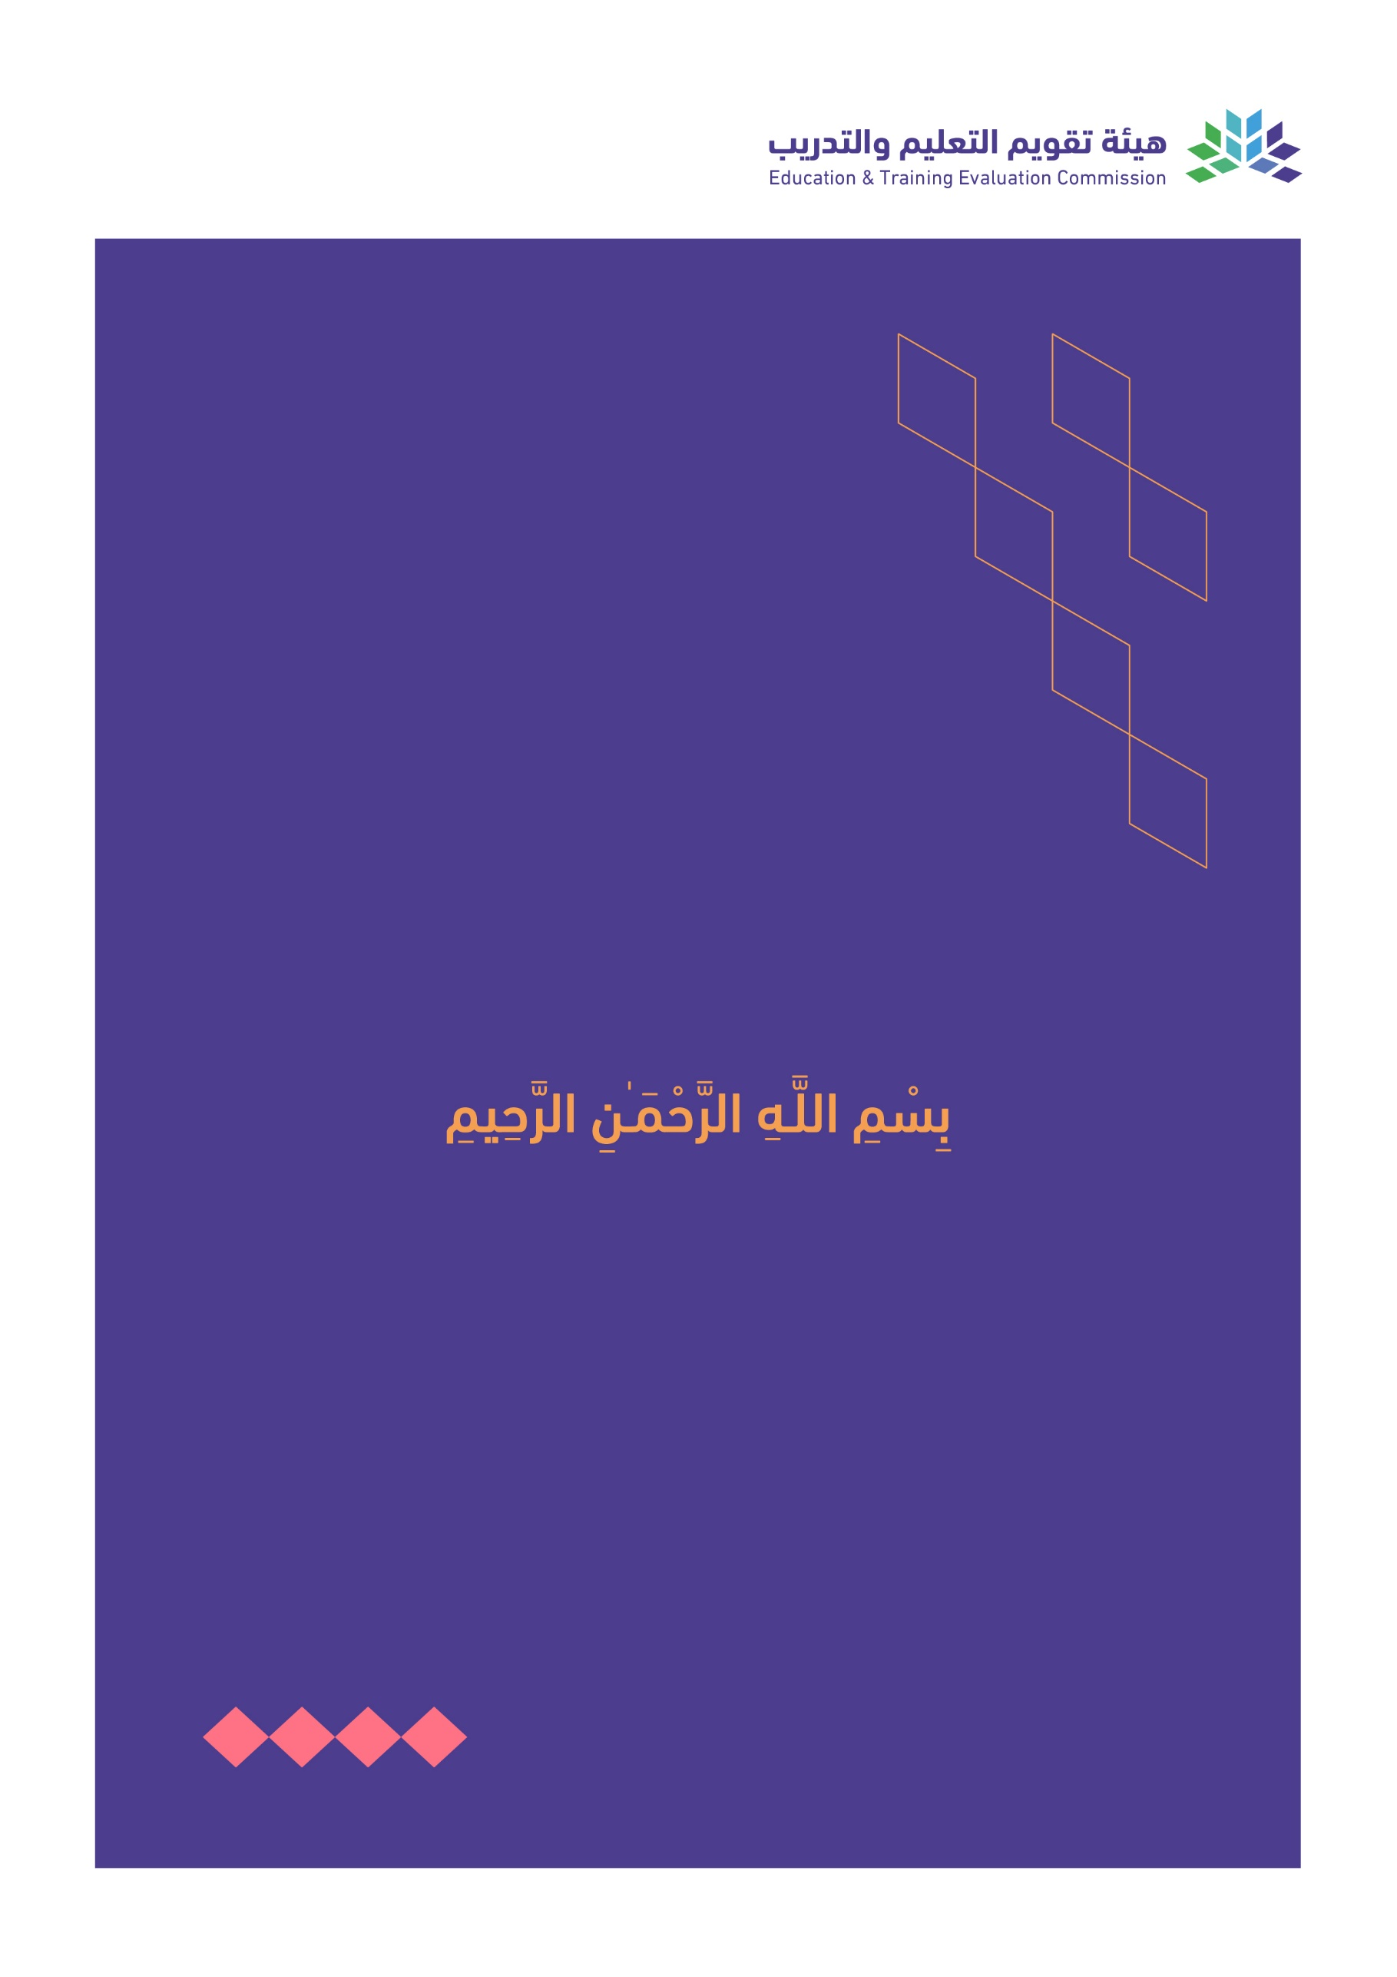

T3

2022

Course Specification

|  |
| --- |
| Course Title:  **Advanced Academic Writing** |
| Course Code:  **MAAL 7101** |
| Program:  **Master of Arts in Applied Linguistics** |
| Department:  **English Department** |
| College:  **Faculty of Languages and Translation** |
| Institution:  **King Khalid University** |
| Version: Updated |
| Last Revision Date: **January 28, 2023** |

Table of Contents:

|  |  |
| --- | --- |
| Content | Page |
| 1. General Information about the course | 3 |
| 1. Teaching mode  2. Contact Hours | 3 |
| B. Course Learning Outcomes, Teaching Strategies and Assessment Methods | 4 |
| C. Course Content | 4 |
| D. Student Assessment Activities | 4 |
| E. Learning Resources and Facilities | 5 |
| 1. References and Learning Resources | 5 |
| 2. Required Facilities and Equipment | 5 |
| F. Assessment of Course Quality | 5 |
| G. Specification Approval Data | 5 |

# A. General information about the course:

|  |  |  |  |
| --- | --- | --- | --- |
| **Course Identification** | | | |
| **1. Credit hours:** | | 5 | |
| **2. Course type** | | | |
| a. | University  College  Department Track Others | | |
| b. | Required  Elective | | |
| **3. Level/year at which this course is offered:** | | | **Level 1/ 1st Semester** |
| 4. Course general Description: This course provides M.A. students with an opportunity to develop, sharpen, and perfect their academic skills. It aims at developing students' critical thinking and academic writing competencies. It helps to develop the writing skills necessary for analysis and presentation of research topics. The completion of the course enables students to write synthesis essays and critiques based on critical reading. | | | |
| **5. Pre-requirements for this course (if any): N/A** | | | |
| **6. Co- requirements for this course (if any): N/A** | | | |
| **7. Course Main Objective(s):** This course lays a foundation for the students’ advanced academic writing skills that enable them to perform their reading and writing assignments and research tasks in the other program courses. | | | |

## 1. Teaching mode (mark all that apply)

| No | Mode of Instruction | Contact Hours | Percentage |
| --- | --- | --- | --- |
|  | Traditional classroom | 40 | 80% |
|  | E-learning | 5 | 10% |
|  | Hybrid   * Traditional classroom * E-learning | 5 | 10% |
|  | Distance learning |  |  |

## 2. Contact Hours (based on the academic semester)

|  |  |  |
| --- | --- | --- |
| No | Activity | Contact Hours |
|  | Lectures | 40 |
|  | Laboratory/Studio |  |
|  | Field |  |
|  | Tutorial |  |
|  | Others (specify) | 10 |
|  | Total | 50 |

# B. Course Learning Outcomes (CLOs), Teaching Strategies and Assessment Methods

| Code | Course Learning Outcomes | Code of CLOs aligned with program | Teaching Strategies | Assessment Methods |
| --- | --- | --- | --- | --- |
| 1.0 | Knowledge and understanding | | | |
| 1.1 | Articulate clearly and accurately the close connection between thinking, reading, and writing | K 1 | Class discussion | PowerPoint presentation about students’ personal reflection on the topic |
| 1.2 | Critically outline the logic of summarizing, paraphrasing, and quoting sources | K 1 | Inductive presentation of examples | Written tests |
| 1.3 | Demonstrate critical knowledge and understanding of the steps of critical reading and critique writing | K 1 | Discussion and illustrations | A critique essay on a published article |
| 1.4 | Differentiate insightfully between explanatory synthesis and argument synthesis | K 1 | Discussion and illustration | Essay |
| 1.5 | Explain academic writing as a recursive process | K 1 | Lecture discussion | Group presentation |
| 2.0 | Skills | | | |
| 2.1 | Give a presentation that reflects on the relationship between thinking, reading, and writing based on students’ personal experience | S 1 | Group reflection on a sample text | PowerPoint presentation about students’ personal reflection on the topic |
| 2.2 | Implement the knowledge of summarizing, paraphrasing, and quoting in taking notes from applied linguistics various academic sources | S 1 | Group discussion of sample summaries, paraphrases, and quotes | Written tests |
| 2.3 | Write a critique essay of a published article based on critical reading | S 1 | Video tutorial and sample discussion | A critique essay on a published article |
| 2.4 | Compose an essay that illustrates the dynamics of explanatory and argument synthesis | S 1 | Lecture discussion and sample presentation | Essay |
| 2.5 | Appraise critically the credibility of academic sources in terms of authority, currency, relevance, audience, and bias | S 1 | Demo and appraisal example discussion | Group presentation |
| 3.0 | Values, autonomy, and responsibility | | | |
| 3.1 | Demonstrate integrity when performing academic writing tasks and assignments (originality, credit to original sources, etc.) | S 1, V 1 | Creating a culture of integrity in classroom | Integrity test |
| 3.2 | Initiate their own opportunities for professional development in advanced academic writing (Joining SIGs, Online training courses, Attending academic events, SAUDI TESOL) | V 2 | Discussing different available opportunities of professional development | Professional development activities report |
| 3.3 | Monitor their learning and performance autonomously (identifying their needs, setting personal learning goals, apply appropriate learning strategies, evaluate one’s outcomes of learning) | V 3 | Student-centered open discussion of their needs, learning goals, employed strategies, self-evaluation methods | Journal |
| 3.4 | Undertake leadership roles in curricular and extracurricular activities (creating teams, leading teamwork, improving team spirit, respect, and cohesion) | V 4 | Group tasks with different leadership roles | Checklists |
| 3.5 | Employ the knowledge and skills students gain from the course in diagnosing and proposing solutions to academic writing problems encountered in local educational institutions. | V 5 | Organize an event to raise students’ awareness of the importance of community service | Reflection tasks |

# 

# C. Course Content

|  |  |  |
| --- | --- | --- |
| No | List of Topics | Contact Hours |
| 1. | Introduction to thinking and writing in college | 2 |
| 2. | Summarizing and paraphrasing sources | 8 |
| 3. | Quoting sources | 5 |
| 4. | Critical reading and critique writing | 10 |
| 5. | Explanatory synthesis | 5 |
| 6. | Argument synthesis | 5 |
| 7. | Writing as a process | 5 |
| 8. | Locating, mining, and citing sources | 10 |
| **Total** | | 50 |

# **D. Students Assessment Activities**

| No | Assessment Activities * | Assessment timing  (in week no) | Percentage of Total Assessment Score |
| --- | --- | --- | --- |
| 1 | Presentations | 2 | 5 |
| 2 | One midterm exam | 5 | 20 |
| 3 | final exam | 11 | 50 |
| 4 | Critique essay | 6 | 10 |
| 5 | Integrity test | 7 | 3 |
| 6 | Journal/Professional Development Report | 8 | 5 |
| 7 | Leadership skills checklist | 3, 8, 10 | 2 |
| 8 | Course utility reflection task | 10 | 5 |

*Assessment Activities (i.e., Written test, oral test, oral presentation, group project, essay, etc.)

# E. Learning Resources and Facilities

## 1. References and Learning Resources

|  |  |
| --- | --- |
| Essential References | Behrens, L., Rosen, L. J., & Beedles, B. (2017). A sequence for academic writing. Pearson Education. |
| Supportive References | Bailey, S. (2014). Academic writing: A handbook for international students. Routledge. |
| Electronic Materials | <https://natureofwriting.com/courses/introduction-to-rhetoric/lessons/hedges-and-boosters/topic/hedges-and-boosters/>  <https://students.unimelb.edu.au/academic-skills/explore-our-resources/referencing/voice-in-academic-writing> |
| Other Learning Materials |  |

## 2. Required Facilities and equipment

| Items | Resources |
| --- | --- |
| facilities  (Classrooms, laboratories, exhibition rooms, simulation rooms, etc.) | A classroom that is adequate for postgraduate students |
| Technology equipment  (projector, smart board, software) | Data display technology |
| Other equipment  (depending on the nature of the specialty) | Program library |

# F. Assessment of Course Quality

| Assessment Areas/Issues | Assessor | Assessment Methods |
| --- | --- | --- |
| Effectiveness of teaching | Students, Instructors, Program Leaders | Tests, Surveys, Interviews |
| Effectiveness of students’ assessment | Measurement and Evaluation Unit | Analysis of course evaluation questionnaires, SPSS Analysis Repot |
| Quality of learning resources | Students, Instructors, Program Leaders | Observations, Surveys |
| The extent to which CLOs have been achieved | Instructors, Program Leaders | Tests, portfolios |
| Other |  |  |

**Assessor** (Students, Faculty, Program Leaders, Peer Reviewer, Others (specify)

**Assessment Methods** (Direct, Indirect)

# G. Specification Approval Data

|  |  |
| --- | --- |
| Council /COMMittee |  |
| Reference No. |  |
| Date |  |